Intuitive Arts Festival

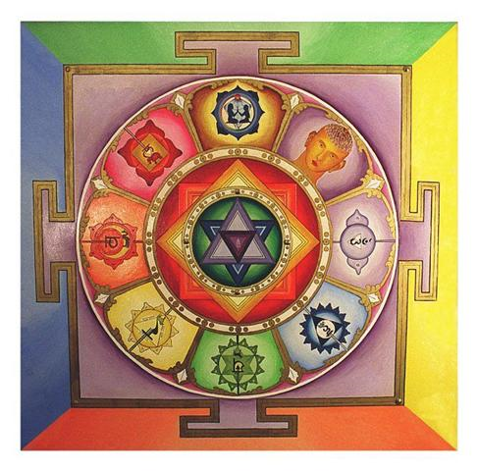

Orange Hall
1620 Fernwood Rd
♥
$10
(Suggested Donation)
Friday, Oct. 23rd
5pm – 9pm
♥
Saturday, Oct. 24th
10am – 10pm

Celebrating Spirituality, Holistic Health, Healing and Psychic Arts

2 Day Workshop Series
Local Exhibitors
Healthy Food and Snacks
Saturday Night Music Social

Check out www.psychicsong.com or call (250) 661-6826 for more information.

Peace ♥ Love ♥ Joy ♥ Health ♥ Vitality ♥ Abundance ♥ Prosperity ♥ Community ♥ Friendship ♥ Knowledge ♥ Wisdom ♥ Clarity ♥ Blessing ♥ Expression ♥ Passion ♥ Diversity

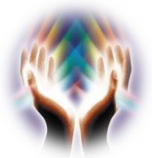
Greg Augustine
(250) 748 - 6626
www.soma4living.com
Somatics, Somatic Rehabilitation, Myofascial Release, Integrative Massage

David J. Nagy
www.intuitiveportraiture.com
(250) 388 - 6249
"Your life-dream through clairvoyant illustration,"

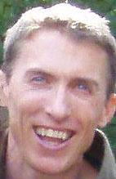
Valerie Carter
(778) 430 - 1015
Reiki Master/Teacher, Deep Emotional Release, Chrystal Chakra Balancing, Shamanic Energy Healing

Linda Beet
www.intuitivearts.ca
(250) 590 - 7953
Tarot, Magic and Ritual, Chakra work, Meditation, Theatre, Music and Astrology

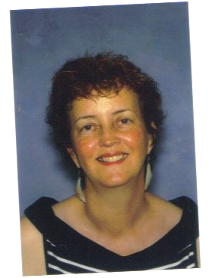
Grace Gerry
www.gracefulsolution.ca
(250) 370-2254
Counseling / coaching for women to promote wellbeing and clear out emotional clutter
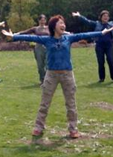
Miho Lindley
www.laughteryoga.org
Phone: 250-391-1117
Laughter Yoga, Quantum-Touch, Arraby’s Aromatherapy, Fucoidan


Yves Vial
(250) 595 – 0083
www.soundhealingcanada.com
El Kalinado, "He who brings peace through sounds," Sound Healing and Literrm

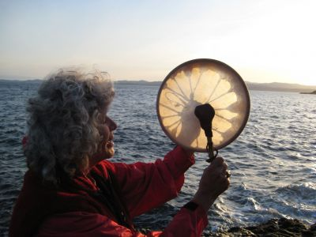
Marianne Sämann Wyss
www.worldgratitudedrummers.org
(250) 382 - 3582
Wholistic Counselling, Energy Healing, Shamanic soul/spirit balancing

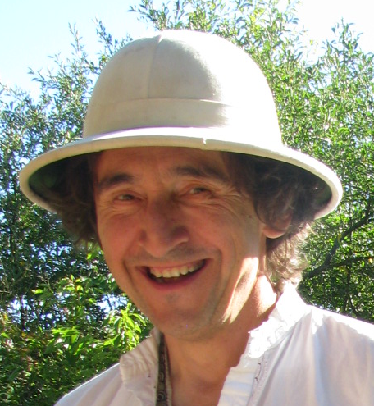

Andrea Mattson
www.psychicsong.com
(250) 661 – 6826
Clairvoyant Tarot, Tasseograpy, Law of Attraction, Creative Visualization, and Meditation, Singer/Songwriter
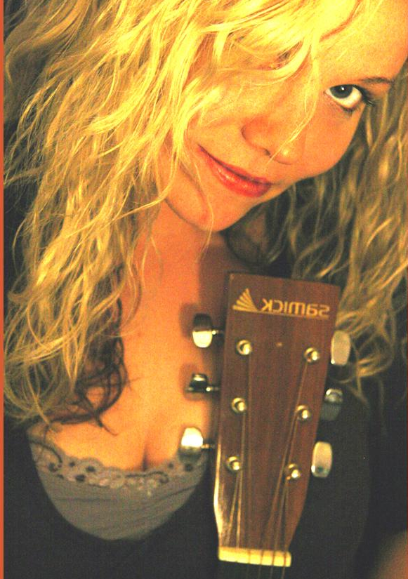

Janis and Siobhan
www.TwoHealingChicks.com
Past lives, Shamanic Healing, Reiki, Crystals and Drums, Intuitive Card Reading
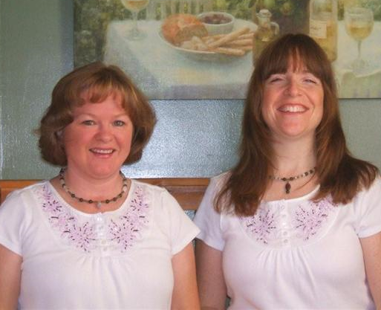

Suzanne Sparling
(250) 370 – 7558
Body/Mind Therapy, Reflexology, LaStone Therapy, Swedish Massage, Reike

Peace ♥ Love ♥ Joy ♥ Health ♥ Vitality ♥ Abundance ♥ Prosperity ♥ Community ♥ Friendship ♥ Knowledge ♥ Wisdom ♥ Clarity ♥ Blessing ♥ Expression ♥ Passion ♥ Creativity

